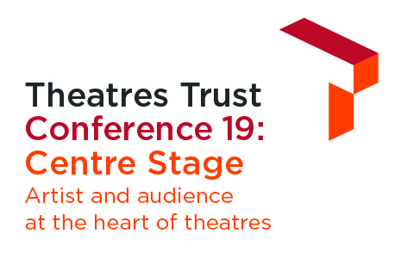

Conference 19 Bursary Application Form
Thanks to the support of ETC, GDS and HQ Theatres, we are pleased to be able to offer bursary places for Conference 19: Centre Stage on Tuesday 15 October at Battersea Arts Centre.
Bursary places are available for:
- Students on higher education courses relating to the themes of the conference
- Emerging artists
- Representatives from small (less than three members of staff) and unfunded theatre organisations.
We can also cover reasonable travel expenses and one night’s accommodation (if needed) for bursary recipients travelling from outside Greater London.
Terms and conditions
Deadline for applications 5pm on Monday 9 September.
Decisions to award bursary places will be made by the Theatres Trust. Unfortunately, we are unable to provide feedback on unsuccessful applications
We will notify successful applicants by 16 September.
Applicants will need to confirm their acceptance of the place by 23 September.
In return for a conference ticket, you must be willing to:
- take part in a promotional photograph with the sponsor and;
- have your name and organisation / university (where applicable) included in the attendees list.
We will pay reasonable travel costs from outside of Greater London e.g. standard class advance purchase. Expenses will be reimbursed upon provision of relevant receipts.
Hotel accommodation can be provided for successful applicants if they are unable to travel to London in one day to attend the whole conference. We will make this booking on your behalf alongside bookings for other conference contributors for a hotel near the conference venue in Battersea.
Apply for a bursary place
To apply, please complete the form below and return it along with your CV to events@theatrestrust.org.uk by 5pm on Monday 9 September.

Application details
Full Name _______________________________________________
Organisation / University (if applicable) __________________________________________
Job Title / Course studying (if applicable) _______________________________________
Address ________________________________________________
________________________________________________________________________
________________________________________________________________________
________________________________________________________________________
Email address ________________________________________________
Phone number ________________________________________________
Twitter handle (if applicable) ________________________________________________

Why you want to attend
Tell us about yourself, your background and experience. Why do you want to attend Conference 19: Centre Stage? How will it benefit your career / practice? What can you contribute to discussions? (No more than 400 words)

Please confirm that if successful, you consent to:
Taking part in a promotional photograph with the sponsor GDS Yes / No
Inclusion of your name and organisation / university in the attendee list Yes / No
Expenses
Will you need to claim travel expenses from outside of Greater London Yes / No

Will you need hotel accommodation for one night prior to the conference Yes / No
Name _______________________________________________
Date _______________________________________________

