Theatres Trust in association with the Wolfson Foundation

Theatre Improvement Scheme Guidance Notes for Applicants

This guidance is intended to support your application to Theatres Trust’s Theatre Improvement Scheme in association with the Wolfson Foundation. The guidance notes will help you understand what we are looking for in each section or question on the application form. We are unable to answer individual enquiries about the scheme due to the number of applications we receive. However, [www.theatrestrust.org.uk](http://www.theatrestrust.org.uk) has more helpful information including the terms and condition of the grant (which should be read in conjunction with these guidance notes) and details of a recording you can watch to learn more.

# Scope of the fund:

Theatre operators can apply for grants of up to £20,000 towards their building or equipment as part of the scheme. There is no match funding requirement although if the project costs are above £20,000 it will strengthen the bid to demonstrate where additional support will be found.

# What we hope to fund:

This scheme will prioritise capital development projects which improve a theatre building’s environmental sustainability and demonstrate how a small intervention can produce big reductions in environmental impact, such as:

* purchase of key plant and machinery
* replacement of inefficient or out-dated equipment
* improvements to building heating or insulation
* planting sedum roofs or green walls
* impactful, high-quality interventions

Previous awards have been issued to venues to:

* Replace or install a building management system (BMS) to improve building management efficiency, reduce energy usage and maximise staff capacity
* Supply new heating or cooling systems to reduce environmental impact and improve audience and artist experience in the auditorium
* Improve draught-proofing of windows or doors to retain heat and save costs
* To replace Tungsten with LED lighting and support purchase of digital lighting operating systems.

To be eligible, venues must:

* own or manage theatres with titles or signed leases of more than 5 years on buildings in England, Scotland, Wales and Northern Ireland
* run a year-round programme of live performance, of no less than 30 performances a year of theatre, dance, comedy, musicals
* have a bona fide UK charitable or not-for-profit legal structure and be able to provide certified or audited accounts for at least two years. This can include local authorities or Town and Borough Councils that own and/or operate a venue
* Organisations previously in receipt of grants from the Theatres Trust (including through this scheme) may not apply until 12 months after the date of receipt of the Final Evaluation Report for that award
* Organisations that have previously received a direct grant from the Wolfson Foundation can apply to this scheme providing it is for a different project
* Have the permission of the property owner and any relevant planning body to do the work required
* Operate theatres that achieve excellence through their producing and programming and / or community engagement and / or architectural significance.

We cannot fund:

* Venues that are primarily cinemas or music venues.
* Works that have already started or are due to start before a decision about our funding is made.
* Revenue costs, including training costs.
* Loss of income related to project installation.
* The cost of building surveys or reports.

We welcome applications from theatre venues across the UK that meet these criteria, whether voluntarily or professionally run.

You will receive a response to your application within approximately 16 weeks after the closing-date, so we are not able to fund work that requires urgent or immediate attention before this time.

# Word count guides:

We ask you to work within the word count guides (where given), making the most of the opportunity to tell us your story while also keeping your information concise.

# Questions:

1. **Your project**

1.1 Please give a one-line summary of your project

This is the opportunity to summarise your improvement works in a brief sentence. The project’s name may be used for publicity and promotional purposes.

Please be clear and concise about what the project is funding i.e. Installation of LED lighting, Improving solar panels

**2. Contact details**

2.1 Name of individual making this application on behalf of the organisation

2.2 Your position/role in the organisation

2.3 Name of organisation (please note that individuals are not eligible to apply)

2.4 Address of organisation/venue operator

2.5 Telephone

2.6 Mobile

2.7 Email

These questions provide us with all the contact data required for the organisation applying for funding.

**3. Theatre details**

3.1 Address of theatre

3.2 Theatre website (if applicable)

3.3. Theatre X (formerly Twitter) (if applicable)

3.4 Theatre BlueSky (if applicable)

3.5 Theatre LinkedIn (if applicable)

3.6 Theatre Facebook (if applicable)

3.7 Theatre Instagram (if applicable)

3.8 Type of charitable or not-for-profit organisation (e.g. charity, CIC, etc)

3.9 Your Company Number (if applicable)

3.10 Your Registered Charity Number (if applicable)

3.11 Your VAT Registration Number (if applicable)

3.12 How long have you owned or leased your theatre?

3.13 If you lease your theatre, what is the remaining term of the lease? (Please note that eligible applicants are required to have leases for five years or more)

3.14 Please provide a copy of your current lease or other proof of the remaining term

3.15 If you lease your theatre, please give the legal name of the freeholder, plus the contact details of the freeholder and/or any head leaseholder

3.16 Please provide your audited or certified accounts for the last two financial years. Below please confirm which years they are from

Space to upload your audited or certified accounts for the last two financial years. Accepted file types: pdf, doc, docx, xls, xlsx. Limit 10MB

Space to provide details if you do not have accounts for the last two years (100 words max)

These questions tell us about your theatre building, and the basis on which it is owned and operated. We request this information, so we understand the context in which your application is being made.

It is a requirement that all applicants have a lease of at least **five years or more**. This is so that any purchase or improvement our funding supports will make a difference to your theatre’s operation for a sustained period.

We ask for two years of annual accounts to ensure you are a going concern and to give us an overview of your current financial position.

**4. Your theatre building**

4.1 How many live public performances are presented in total across your auditoriums in on year?

4.2 Please note that to be eligible, your venue must present **at least 30 public live performances per year** of theatre, dance, comedy, musicals. Please complete the table below with:

* Current seating/standing capacities of your theatre. Please differentiate between theatre spaces (providing any names of theatre auditoria) if you have more than one auditorium.
* How many public live performances you presented in your last complete year of operation, and how many people attended these performances. By your last complete year of operation, we mean the last financial year for which you have data.

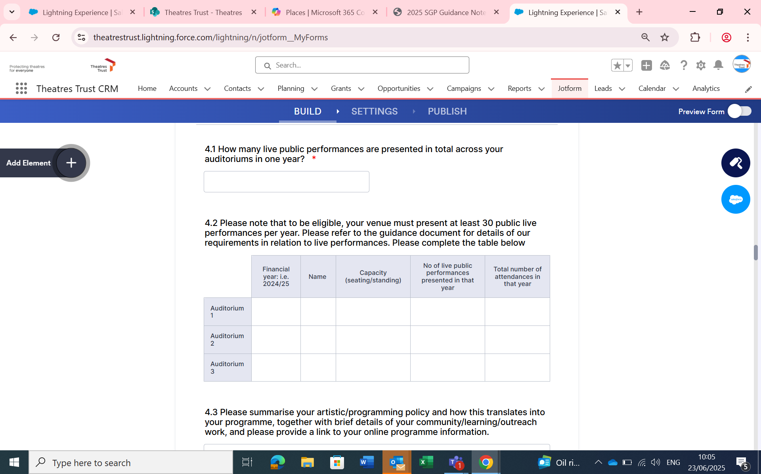Please give us the total number of performances that took place in your venue during this period. Please count each time a performance takes place as one performance, for example if you have a production playing seven times over the course of five days, please include all seven performances in your total.

We ask for this information so we know the scale of your audience and how many people will potentially benefit from the work we might fund.

4.3 Please summarise your artistic/programming policy and how this translates into your programme, together with brief details of your community/learning/outreach work, and please provide a link to your online programme information (250 words max)

4.4 Please define how your project achieves excellence through its artistic and community works (250 words max)

4.5 Please confirm whether you are currently receiving regular funding from one of the UK national arts councils (Arts Council England, Arts Council Wales or Arts Council NI) or arts development agency (Creative Scotland) and/or whether you are in receipt of revenue funding from a local authority/local authorities

These questions help us understand your ambitions as a venue, the kind of programme you offer and the scale of audiences you play to. Your answers will give us a picture of your venue’s role and significance.

We ask you to summarise your artistic/programming policy together with details of your community/learning/outreach work. This is your chance to explain how you define and measure excellence in your organisation, outlining your achievements and your ambitions.

**5. Improving sustainability**

5.1 Please describe the improvement work that you plan to undertake and how you would use this grant. Ensure you succinctly explain the exact works involved, and whether they fit into a larger phased scheme (if applicable) (250 words max)

5.2 Please also five details of how you will measure the impact of your proposed work and achieve best practice in theatre design (250 words max)

5.3 Have you used the Theatre Green Book and/or the Building Survey Tool to help identify priority sustainability intervention for your building? Yes/No

5.4 If so, how does this project help you meet one or more of the identified priority interventions? (100 words max)

5.5 Have you already secured quotes for the goods/services related to this application? Yes/No

5.6 If yes, please provide details and include PDF copies of these quotes as attachments to your application

5.7 Please provide photos and/or plans if these are necessary to explain the works

In this section, we ask you to explain how you would use this grant. Please give details of the improvement works that you plan to undertake. Ensure you succinctly explain the exact works involved, and whether they fit into a larger phased scheme (if applicable). The [Theatre Green Book](https://theatregreenbook.com/) provides guidance that will be useful, including a new Building Survey Tool.

Please also give details of how you will measure the impact of your proposed work and achieve best practice in theatre design.

**6. Project management and delivery**

6.1 Please give details of who will manage the Project and their credentials (if known)

6.2 If the owner of your theatre is different from the leaseholder of your theatre please describe if you already have the permission you need to undertake your Project or when you intend to secure this permission. If you have permission, please attach a letter confirming this from the building owner (100 words max)

6.3 Will your Project require planning permission/listed building consent/conservation area consent? Yes/No

6.4 What is the timetable for the implementation of your Project? (100 words max)

6.5 When do you anticipate spending a grant from the scheme? A grant must be spent within one year of the date you receive your offer letter. Please note that after the application deadline, it will be up to 16 weeks before decisions are made. (100 words max)

6.6 Please outline the risks you anticipate may be associated with the completion of your Project and how you plan to mitigate them (100 words max)

These questions give us information about how and who will manage your project and whether additional permissions or consent is required from other parties before you can commence.

You will receive a response approximately three months after the application closing-date, so we are not able to fund work that requires urgent or immediate attention before this time.

**7.** **Project cost**

7.1 What is the total net cost of your Project (excluding VAT)

7.2 How much are you applying for? (note the maximum grant for this scheme is £20,000)

7.3 If you require any additional funding to support the project, how much is already in place, and what are your plans to meet any funding gap?

7.4 Please provide a budget for both costs and income for the project, identifying income sources as confirmed or expected. Please clearly explain the VAT position of the project.

Please provide quotes for delivering the project that relate to the figures in your budget, so we know what your budget is based on. We do not require you to present more than one quote as part of a tendering process.

Please double check your budget and make sure it tells us the same information as you include in the application form. You are welcome to include a reasonable contingency in your budget (up to 10%) as we recognise that quotations may change by the time you come to do the work.

Please note, we cannot pay for staff time, training, loss of earnings or any revenue costs.

7.5 Have you previously received a grant from this or any other Theatres Trust grants scheme? Yes/No

7.6 If so, what date did you submit your Evaluation Form? (Please note, you cannot apply to this scheme until 12 months after submission of your Final Evaluation Report for any previous award)

7.7 Do you have a current application to any other Wolfson Foundation funding schemes, or have you received funding from the Wolfson Foundation towards this project? Yes/No

These questions help us understand what part our funding will play within your project and to quantify the anticipated costs. We ask you to give the figures *net of VAT* and that you clearly explain the VAT position of the project.

We can pay up to 100% of the costs involved and there is no requirement to have other funding in place. However, if your project costs more than you are asking for from Theatres Trust, we would like to know how you plan to raise the other funds and how confident you are that this money will be received.

# Supporting documents

1. Lease (required)
2. Annual Accounts for two previous years (required)
3. Quotes and/or estimates for building works (required)
4. Photos/plans to explain the scheme (optional)
5. Budget (required)

# What happens next?

We will acknowledge receipt of your application within two working days

Applications will be acknowledged when received and logged. If you do not receive an acknowledgement within two working days of submission, please email [info@theatrestrust.org.uk](mailto:info@theatrestrust.org.uk) to confirm receipt of your application.

Theatres Trust will not be responsible for the non-delivery of your application due to any technological reason. It is the applicant's responsibility to ensure that their application has been received.

Please note that you may be asked to provide further details on your project for the Theatres Trust to make a decision on your application.

We will assess the application against the following criteria:

## Impact and significance:

* How effectively the applicant makes a compelling case for a capital development, refurbishment or equipment purchase to improve environmental impact of the building.
* How effectively the applicant makes a case for the development being important now.
* The role and significance of venue to its communities and users.

## Management and risk:

* How effectively the applicant illustrates that the project is achievable within the value of the fund (up to £20,000), based on a budget and quotes that provide appropriate costings and details of any other income required.
* How effectively the applicant demonstrates that the project will be well managed financially and operationally by an experienced team.
* How effectively the applicant shows an understanding of the risks involved, has plans for potential adaptations required and has team in place to manage and offset.
* To know that the project is achievable within the timescale of the fund.

Balancing criteria

* As the national body for theatres in the UK, geographic spread will be taken into account when making award decisions.

We will let you know the outcome of the application within approximately 16 weeks of the closing date. Grants will be awarded in line with the funding request.

**If successful,** we will send you an offer letter, bank details form, grant agreement and terms and conditions.

Your grant will be paid to you in full once you tell us that the work is due to start. The grant must be claimed within one year of the date of the offer letter.

Once you let us know that the project is due to start, we will issue you with an evaluation report form which we you must send back to us within six months of completion of the project in order that we can assess the impact of our support, create case studies and feedback to our partners. You may not re-apply for a Theatres Trust Grant until 12 months after the date of receipt of your final Evaluation Report.

**If unsuccessful,** we will send you an email with a brief indication of why you have not been successful and providing general feedback. Unfortunately, we are not able to provide any further detailed feedback due to the volume of applications we receive. You may re-apply in future rounds.

**Theatres Trust, July 2025**